EUREKA NEWSLETTER No 11
JANUARY 2025 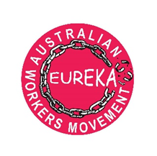

IN MEMORY OF SPIRO ANTHONY (9/8/45- 12/11/24)
Many will have heard of the recent death after a short illness of Spiro Anthony, one of the founders of Eureka. It has left all of us both shocked and sad. Spiro was irreplaceable. A tribute is given below. If you can, please come along to the following events in solidarity.

Upcoming events
SYDNEY
Presentation and discussion: Making sense of the current international situation – Europe, Middle East, Pacific
11 am – Sunday 8th December
Ashfield Library Study Room,
Level 3 Ashfield Civic Centre, 260 Liverpool Road, Ashfield.
(A short walk from Ashfield station)

NEWCASTLE
10am Friday 20th December
Clocktower Hamilton
Join us for the last activity of the year :
Bulk billing campaign -leaflet and petition

--------------------------------------------------------------------------------------------------------------------------------------------------------------------

Spiro Anthony (9.8.45 to 12.11.24)
Comrade, leader and political thinker

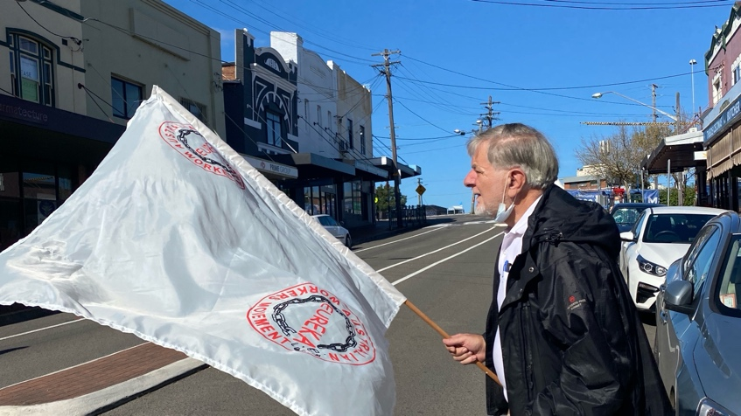
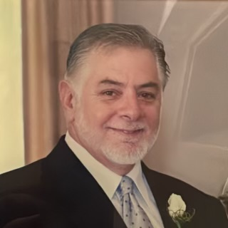

Spiro Anthony was a founding member of Eureka. He was a visionary in that he recognised the need for an organisation that prioritised peoples’ needs. He saw Eureka as filling a gap in Australia’s political movement and as an important part of the path to socialism. In October, weeks before Spiro left us, Spiro wrote an important speech on the lessons from the Great October Socialist Revolution. Among the lessons that he identified was the importance of the workers movement having connections with other sections of society. He saw that in Australia, Eureka plays this role. He gave the following example:
When nurses went on strike in Sydney, Eureka, our mass organisation, called on other workers and other sections of the community to participate in solidarity actions outside the public hospitals.
At Spiro’s initiative, Eureka stood candidates in the recent NSW local elections. This was an important channel to communicate Eureka’s platform and bring people closer to the movement. He also led the strategy in Eureka’s protests against education funding cuts and increased health costs for people, and he contributed to rallies condemning the actions of the murderous Israeli state in Palestine and Lebanon. He not only formulated many of Eureka’s documents but also painted the placards and carried the banners.
Spiro’s lifelong commitment to social change and his unwavering recognition that socialism is the only way to provide for workers’ needs began in his early years. He was the child of Peter Anthony who was born in Trikomo in Cyprus and Thalia Tarifas whose parents were from Ithaca in Greece. Both his parents were communists and this had a significant impact on Spiro’s ideological development. Born in Newcastle, he had a working class upbringing as one of three children raised by a single father, having lost his mother as a young child.
Spiro’s political contribution grew following his move to Sydney in the 1960s. He was involved in the struggle against the Vietnam War and became a member of the Communist Party of Australia and the National Secretary of the Young Socialist League, where he helped build a strong and vibrant movement. He travelled overseas to learn about developments in the socialist countries of the USSR and GDR. He was also a union delegate in the Public Service Association.
Spiro worked as a psychologist until only a month ago. His approach to psychology was uniquely analytical and humanist. He had a strong sense of compassion for his patients and their struggles and devoted deep attention to their treatment, and also willingly helped those who sought his advice outside of work.
As a psychologist he played a leading role in Psychologists for Peace, which was a group of the Australian Psychological Society that responded to the threat of nuclear war during the Cold War and promoted values of peace and humanity.
In all his endeavours, Spiro directed his work to changing society. Socialism would create a higher form of humanity where people’s needs would be met and peace and bonds of human solidarity would flourish. His integrity to this core value lasted his entire life.
Spiro will be missed by his comrades in Eureka who will continue to work in his honour and in memory of the political and ideological guidance he provided for many years.
The funeral service commemorating Spiro Anthony can be viewed at:

https://www.youtube.com/watch?v=o5Umf4B0jE8&t=1s

For the grandchildren’s release of the peace doves for Spiro see:

https://www.youtube.com/watch?v=cusbm31Lhfw

Next Newsletter: Recent presentation on one of our basic needs- clean water. “WATER-NOR ANY DROP TO DRINK “ ;

CONTACT US ON: eureka.awm@gmail.com
Facebook: EUREKA AUSTRALIAN WORKERS MOVEMENT
YouTube: EUREKA AUSTRALIAN WORKERS MOVEMENT
View our website : eureka.australianworkersmovement.au

