EUREKA NEWSLETTER No 13
MARCH 2025
THE STOCKADE
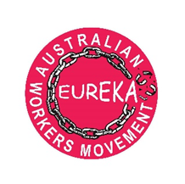
Upcoming events
SYDNEY
6/4/25 -PRESENTATION AND DISCUSSION UPCOMING FEDERAL ELECTIONS
Redfern -contact Dorothy 0417049358 or jabdor@hotmail.com

----------------------------------------------------------------------------------
--------------------------------------------------------------------------------------------
Eureka recently organised a very successful function for International Womens Day

Eureka -Australian workers movement, is a broad organization that aims to rally workers and ordinary people in defence of basic needs such as well-paid secure work, access to the best available health and education services, affordable housing, energy, transport, and a safe and healthy work and community environment. Contact:

CONTACT US ON: eureka.awm@gmail.com
Facebook: EUREKA AUSTRALIAN WORKERS MOVEMENT
YouTube: EUREKA AUSTRALIAN WORKERS MOVEMENT
View our website : eureka.australianworkersmovement.au

