EUREKA NEWSLETTER
No 20 February-March 2026

THE STOCKADE
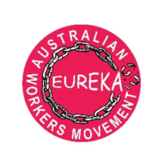

Upcoming Events

SYDNEY
International Women’s Day 2026 Event
Saturday, March 28, 1pm – 3pm

Worldwide, women demand to be safe at home and at work!
Standing together for our rights and our needs!

War, racism, violence in the streets and at home, bullying and sexual harassment at work, economic discrimination and inadequate services in health, education and childcare all make women unsafe.
Together, we can affect real change!

INTRODUCTION

Thalia Anthony is Professor of Law, author, a trade unionist and an activist

SPEAKERS
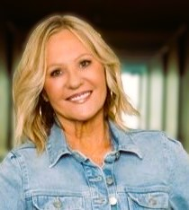
INGA LIE
Inga Lie is a mum, #1 bestselling author, social worker, feminist and activist, Buddhist and music lover.
She has worked in child protection, criminal justice, health, Centrelink, domestic violence, sexual assault and education.
Her book, It’s a Kind of Magic, shares short stories about kindness, belonging and inclusion, written, in part, as a way to heal from workplace bullying.
She’s passionate about truth-telling, systemic change, self-care, kindness and inclusion and ending bullying and gender-based violence. Proud of her Norwegian heritage, she lives on Darkinjung Country.

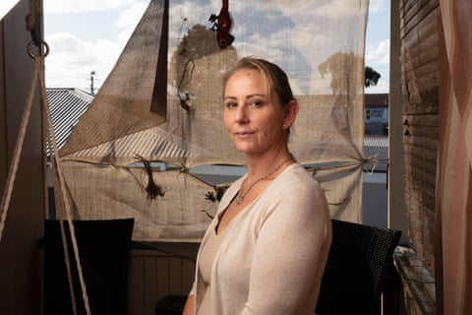
Credit: Russell Shakespeare/The Guardian
RHONDA ‘POSS’ DAVIS
Rhonda “Poss” Davis is a proud Kamilaroi woman from Moree, a single mum of four and grandmother of two. A domestic violence survivor and former prisoner, Poss is known for her generosity and resilience. She has spoken at NSW Parliament House about the challenges women face in the criminal justice system and met with Judge Matthew Myers AM during the Inquiry into the Incarceration Rate of Aboriginal and Torres Strait Islander Peoples. She can operate anything from a bobcat and excavator to a forklift and skillfully polish furniture like no other. She lives in Coffs Harbour on Gumbaynggirr Country.

National Centre of Indigenous Excellence (NCIE)
Conference Centre
166–180 George St, Redfern
Free Admission – Light refreshments 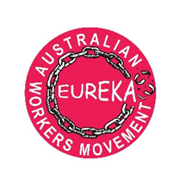 RSVP: jabdor@hotmail.com

````````````````````````````````````````````````````````````````````````````````````````````````````````````````````````````````````````````````````````````````````````````````````````````````````````````````````````````````````````````````````````````````````````````````````````````````````````````````````````````````````````````````````````````````````````````````````````````````````````````````````````````````````````````````````````````````````````````````````````````````````````````````````````````````````````````````````````````````````````````````````````````````````````````````````````````````````````````````````````````````````````````````````````````````````````````````````````````````````````````````````````````````````````````````````````````````````````````````````````````````````````````````````````````````````````````````````````````````````````````````````````````````````````````````

THE WAR IN THE MIDDLE EAST

The US and Israel launched an unprovoked attack on Iran. Thousands of Iranians have been killed, as well as others in the Middle East. For the people of the Middle East, war has shattered that most basic of all needs - a safe environment in which to live. It has been replaced by death, destruction and insecurity.

But the war also impacts all the peoples of the world. In Australia, workers and others,, already struggling with a cost of living crisis, must now bear the burden of rising petrol and diesel prices (transport is essential for most workers in order to get to their job and earn an income). The price of food and groceries will rise, and some workplaces have already shut down and laid off workers. The latest was a mine in WA who laid off a workforce of FIFO workers, because of diesel shortages. The Reserve Bank has increased interest rates largely in response to the inflationary pressures of the war. More people will not be able to afford a home and many on existing mortgages will reach crisis point.

The only people who will benefit from the war are the armament corporations and many of the rich who have switched their investments into the war industry.

Eureka plans to run a campaign highlighting the effects of the Middle East war on the cost of living in Australia, and to call on the Australian government to stop actions that are only fuelling the conflict, such as the sending of warships and personnel to the Middle East.

THE EPSTEIN FILES

The ruling class throughout history have abused and oppressed women. The current ruling class – big businessmen and their hangers on (politicians, senior public servants)-are no exception. The forced release of some of the US government files on Jeffery Epstein, an abuser and procurer of girls and young women, reveal the involvement of a range of businessman and politicians in the abuse of these women. A member of the old ruling class- the monarchy- has been highlighted in the abuse scandal. Perhaps to create a diversion. However, will we ever see the full exposure and prosecution of the big businessmen and politicians that are at the heart of the scandal?

-----------------------------------------------------------------------------------------------------------------
Eureka -Australian workers movement, is a broad organization that aims to rally workers and ordinary people in defence of basic needs such as well-paid secure work, access to the best available health and education services, affordable housing, energy, transport, and a safe and healthy work and community environment.
CONTACT US: eureka.awm@gmail.com
Twitter: (X): Eureka AWM
YouTube: EUREKA AUSTRALIAN WORKERS MOVEMENT
View our website : australianworkersmovement.com.au

